Configure HA Proxy Server:
Launch 3 ec2 instances name as Server1, Server-2, HA-Proxy-Server.
Server-1 Steps:
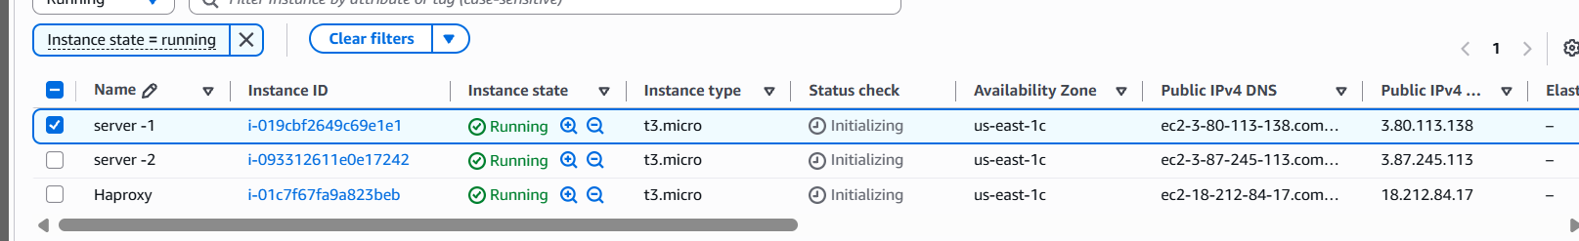
Run following command to Access the Server-1
- ssh -i your-key.pem ec2-user@Pubipaddress of Server-1 instance
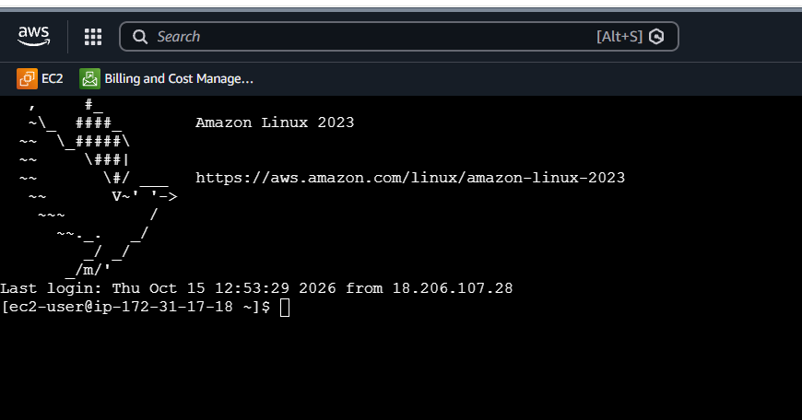
- sudo -i
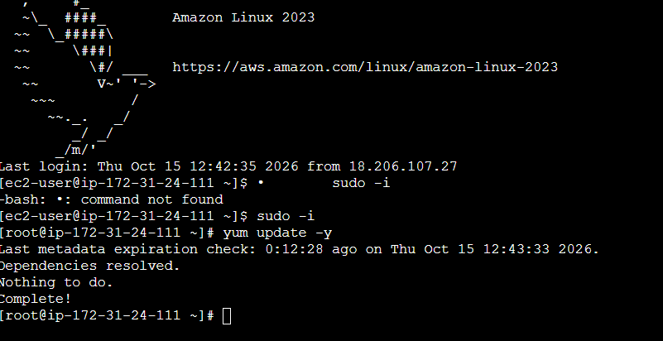
- yum update –y
- yum update –y
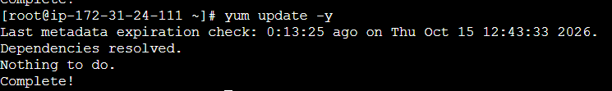
- Yum install httpd -y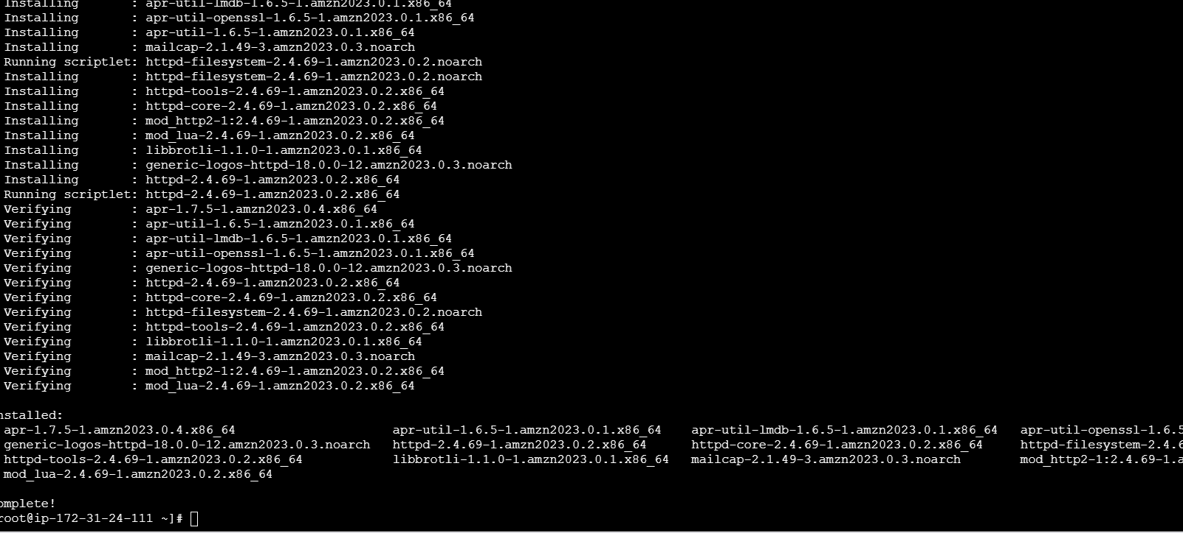

- Vi /etc/hosts
- Add HA-Proxy-Server Pubic IP Address
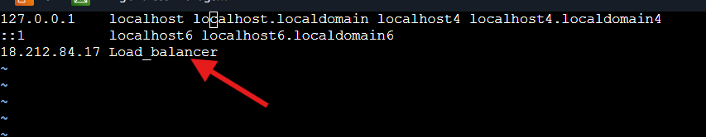

Run below command on Server-1
ping load_balancer -c 4

- systemctl start httpd
- systemctl status httpd
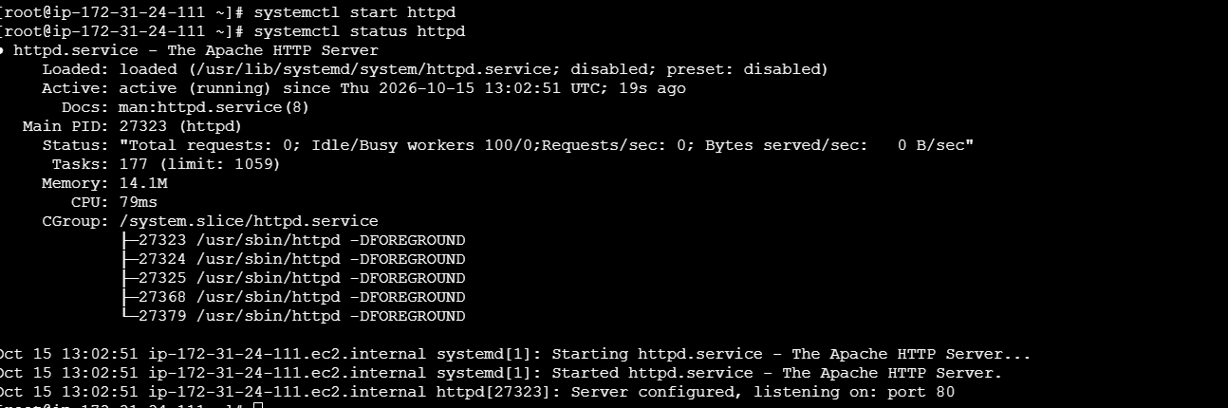
Browse with Server-1 Public IP address:80 it will work
Server-2 Steps:
Run following command to Access Server-2
- ssh -i your-key.pem ec2-user@Pubipaddress of Server-2 instance
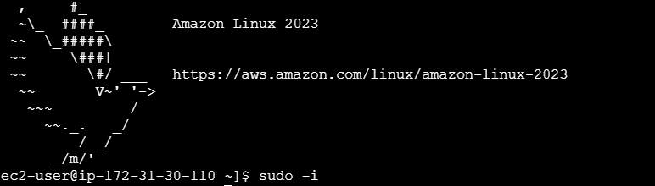
- sudo -i
- yum update -y
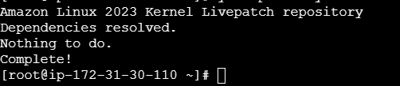
- yum install nginx -y
- sudo amazon-linux-extras install nginx1 -y
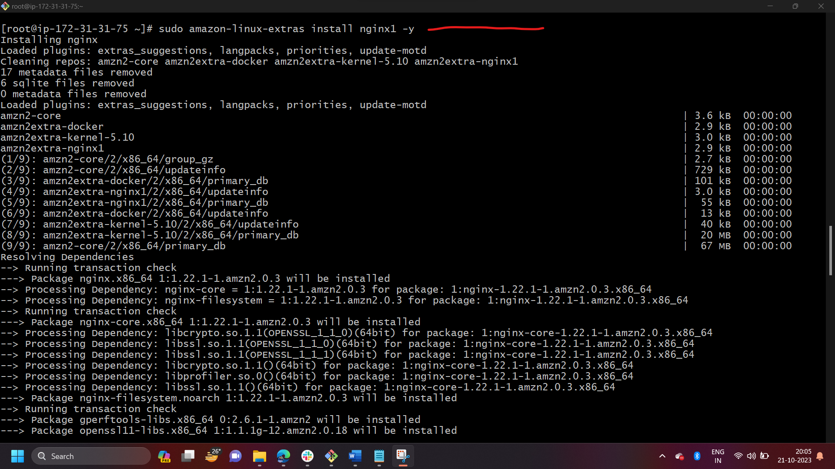
- vi /etc/hosts
- Add HA-Proxy-Server Pubic IP Address

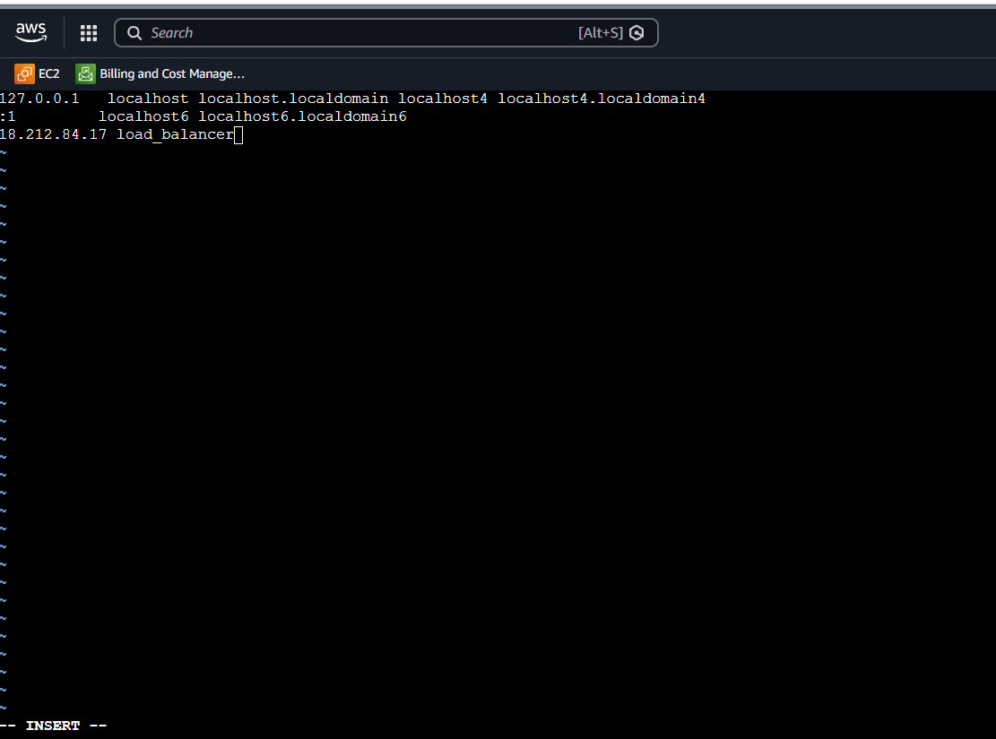
Run below command on Server-2
ping load_balancer -c 4
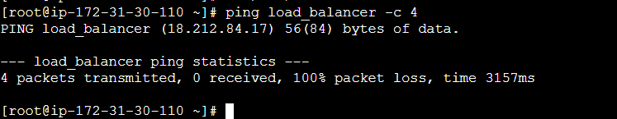
- systemctl start nginx
- systemctl status nginx
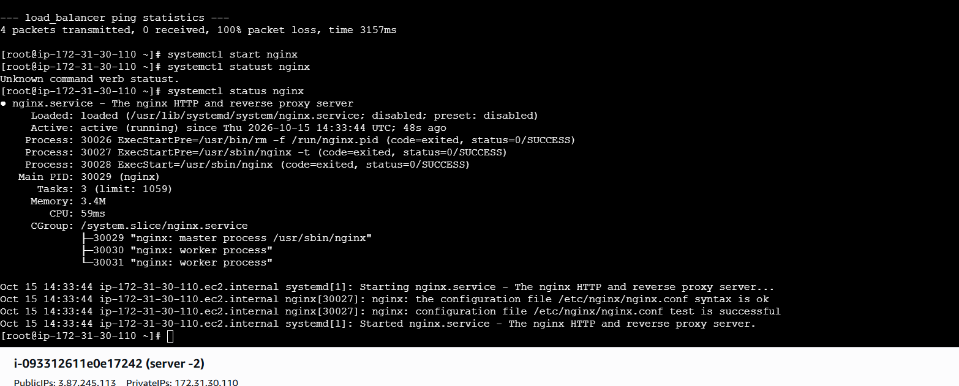
Browse with Server-2 Public IP address:80 it will work
HA-Proxy-Server Steps:
Run following command to Access HA-Proy-Server
- ssh -i your-key.pem ec2-user@Pubipaddress of HA-Proxy-Server instance

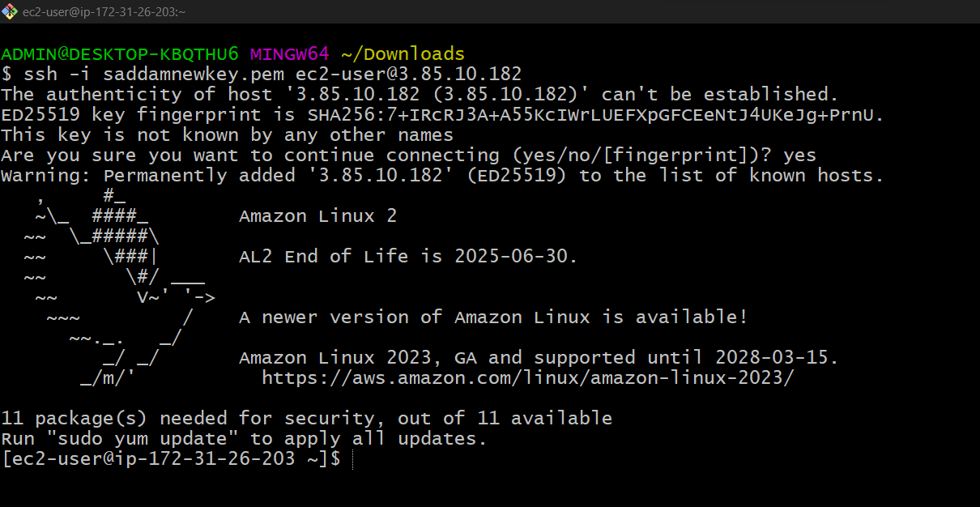
- sudo -i
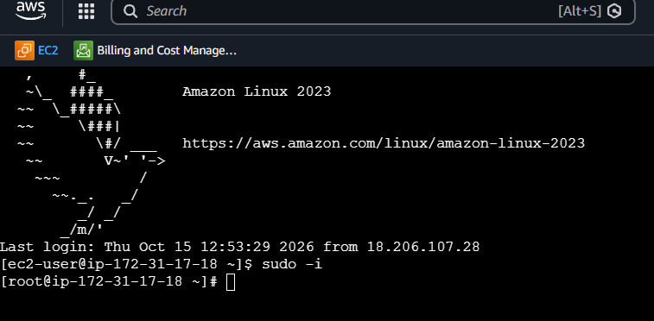
- yum update -y
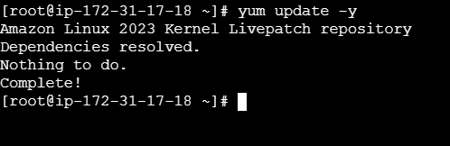

- yum install haproxy -y
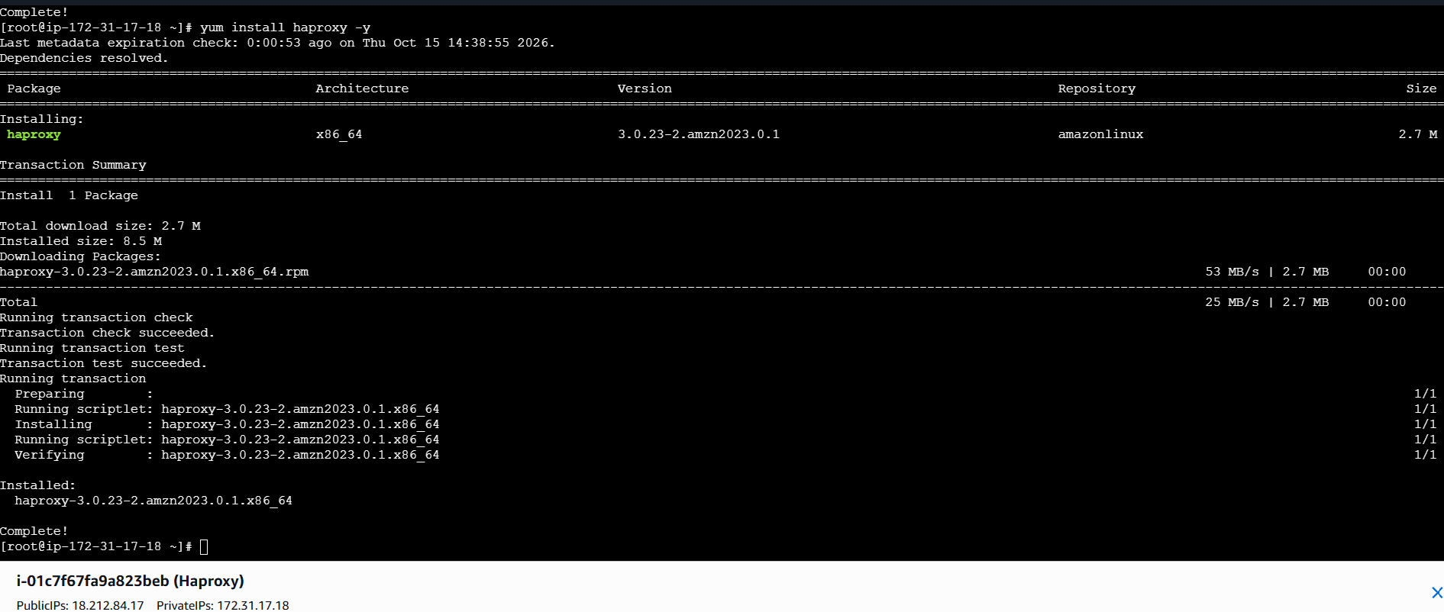
- vi /etc/hosts
- Add Server-1, Server-2 Public IP’s
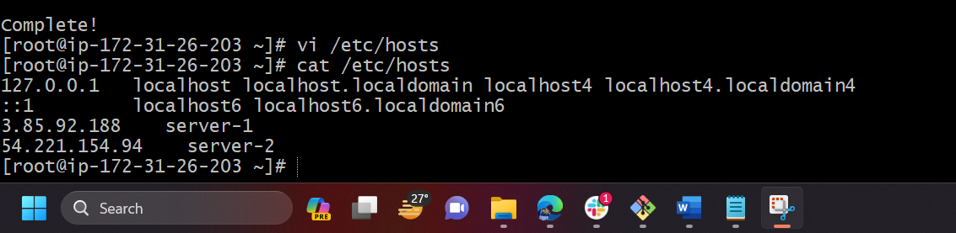

- vi /etc/haproxy/haproxy.cfg
- Add Server-1, Server-2 public IP’s
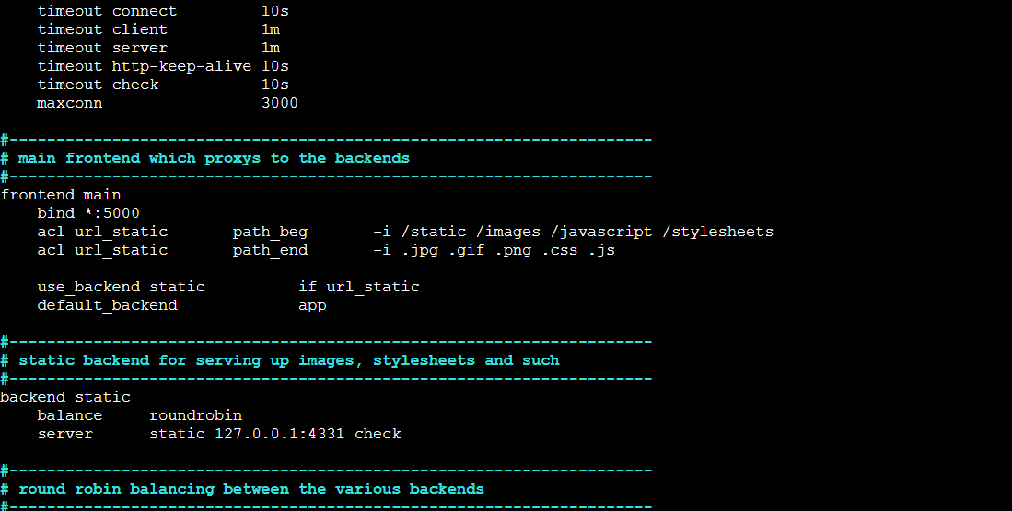
- systemctl enable haproxy
- systemctl start haproxy
- systemctl status haproxy
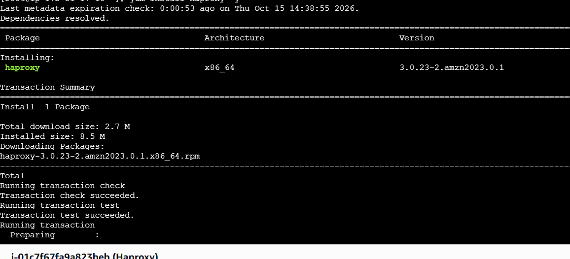
- now browse with HA-Proxy-Server PublicIP:80 it will distribute load to Server-1, Server-2

